Low Level Design

Analyzing Swiggy

|  |  |
| --- | --- |
| Written by | Author 1 |
| Document Version | 0.1 |
| Last Revised Date |  |

Document Control

Change Record

|  |  |  |  |
| --- | --- | --- | --- |
| Version | Date | Author | Comments |
|  |  |  |  |
|  |  |  |  |
|  |  |  |  |

Reviewer

|  |  |  |  |
| --- | --- | --- | --- |
| Version | Date | Reviewer | Comments |
|  |  |  |  |

Approval Status

|  |  |  |  |  |
| --- | --- | --- | --- | --- |
| Version | Review Date | Reviewed By | Approved by | Comments |
|  |  |  |  |  |
|  |  |  |  |  |

Contents

1. Introduction…………………………………………………………………………………4

1.1 What is low level design document?.............................................4

1.2 Scope…………………………………………………………………………………………4

2.Architecture…………………………………………………………………………………5

3. Architecture Design…………………………………………………………………….6

3.1 Data Description……………………………………………………………………….6

3.2 Data Transformation………………………………………………………………..7

3.3 Data preparation……………………………………………………………………..7

3.4 Data insertion in Power BI……………………………………………………….7

3.5 Deployment…………………………………………………………………………….8

4. Unit Test Cases………………………………………………………………………….9

**1.Introduction**

1.1 What is low level design document?

The main aim of the LLD or low level design document is to give the internal logic design of the actual program code for the Analyzing Swiggy dashboard. LLD describes the implementation of the class diagrams with the methods and relations between classes and program specifications so that the code can directly be created from the document itself.

1.2 Scope

Low level design is a component level design process which includes a step by step implementation. This process can be used to create software architecture , data structures and etc. The data organization defined during the requirement analysis and then used in data design.

**2. Architecture**

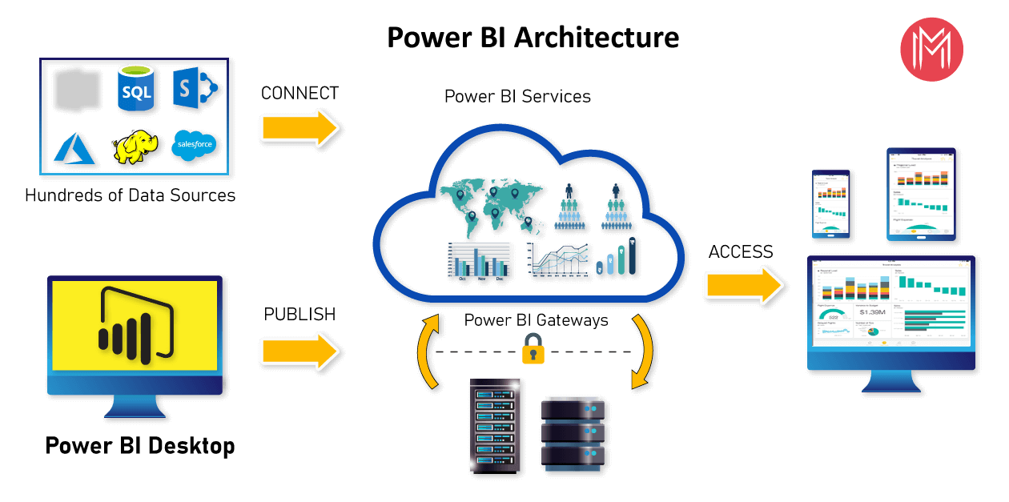

Power BI server Architecture

Power BI architecture is built on Azure. Multiple data sources are supported by Power BI. Power BI desktop is used to create interactive reports and stunning dashboards on the dataset. Power BI gateway is connected to on premises data sources for continuous data for reports and analysis.

Power BI service is the cloud service which is used to publish the reports and dashboards to the web.

Power BI is supported over Android, iOS, windows platforms.

1. Power BI gateway/Connectors:

Power BI gateway is connected to on premises data sources for continuous data for reports and analysis.

2. Power BI service:

Power Bi service is the cloud service which is used to publish the reports and dashboards to the web.

Components of Power BI:

1. Power Query

- Data transformation engine which is used to discover , connect , combine and refine the data.

- Which is used to transform the data.

2. Power Pivot

- Data modelling technique which is used to create models, relationships and to perform calculations.

3. Power view

- available in excel , sharepoint , SQL server and Power BI

-Used to create interactive charts , graphs

- Used to filter data for the visuals

4. Power map

- 3D visualization tool which is used to create map of the data and plot million rows of data visually on Bing maps in 3d format.

- Used to give the latitude , longitude, country , city , state etc.

5. Power BI desktop

- Used for power query , power view , power pivot for developing and driving analysis and insights from the data.

6. Power Q&A

- Used to explore the data

- Used to give more insights from the data.

M formula language:

* The power query is used to filter and combine the data from varied data sources.
* The power query operations are performed by use of M query language.
* It is functional and case sensitive.

**3. Architecture Design**

3.1 Data Description

The dataset contains the data about the swiggy outlets in the Bangalore city.

The given dataset contains the columns:

1. Shop_Name: The names of the shops which swiggy uses in the Bangalore city.

2. Cuisine: The dishes and cuisines which swiggy owns from the shops.

3. Location: The location of the shops in the Bangalore city.

4. Rating: The rating of the shops in the scale of 5.

5. Cost_for_Two: The cost of cuisine for 2 heads

3.2 Data Transformation

The process of data transformation includes:

1. Converting data types

2. Removing columns

3. Creating columns

4. Filtering null values

5. Filtering missing values

6. Removing unwanted data

3.3 Data Preparation

Creating another column for calculating the cost per head from the column Cost_for_Two

Using the formula: cost_per_head=Cost_for_Two/2

Creating Count column for getting the count of frequent ratings

Removing Count_for_Two column from the dataset.

Removing missing values ‘—’ from the dataset and filtering null values.

3.4 Data insertion in Power BI

Step1: Configuring Power BI

Launch Power BI application when downloaded , and then the pop up dialogue box will appear which will ask for get the data. Click on get the data , it will ask you to select the source of data from the list of options like text/CSV, web , excel and etc.

In this case , the dataset is in the format of CSV, load the dataset and make the transformations further and apply the changes.

The window will look like this:

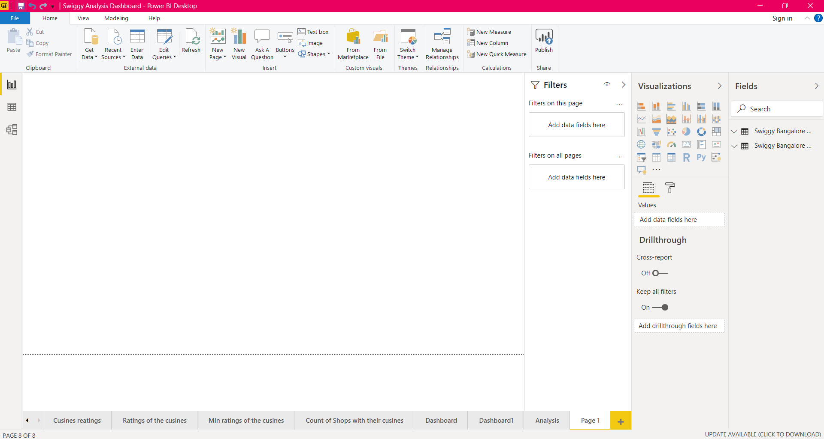

The reports and dashboards can be shared as file and saved as a power bi file in .pbix format.

3.5 Deployment

The reports and dashboards can be published on web using Power BI

Service. The Power BI service asks for work email or the pro license/ premium license of individual to login and publish on the web.

Or else, the file can be saved in the form of .pbix format and can be shared across the platforms.

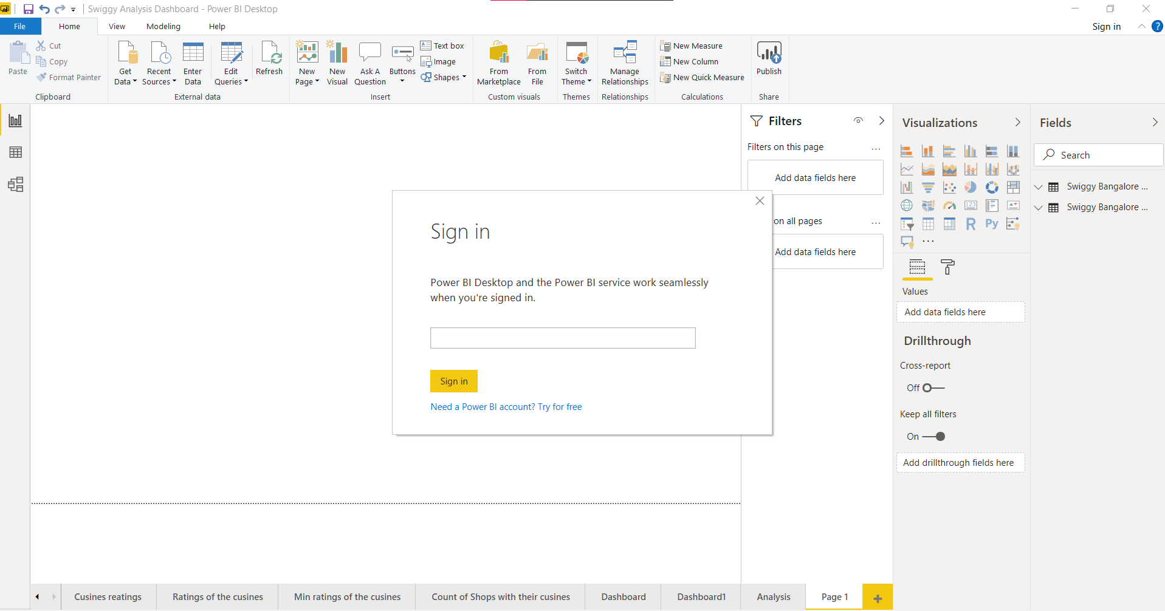

**4. Unit Test Cases**

|  |  |
| --- | --- |
| Test case description | Expected results |
| Location parameter filter | It will give the dropdown list for making changes in the ratings of minimum cuisines |
| Location parameter filter | It will give the dropdown list of the locations for making changes in the shops and their ratings |
| Location filter | It will give the dropdown list of the locations for making changes in the cuisines and ratings |
| Cuisine slicer | The slicer will list out the cuisines for making the changes in minimum cuisines ratings and shop ratings |
| Location slicer | The slicer will list out the locations for making changes in the ratings of the cuisines. |